**Data Flow Diagram:**

Project Design Phase-II

Data Flow Diagram & User Stories

|  |  |
| --- | --- |
| Date | October 2022 |
| Team ID | PNT2022TMID30749 |
| Project Name | Skill and Job Recommender |

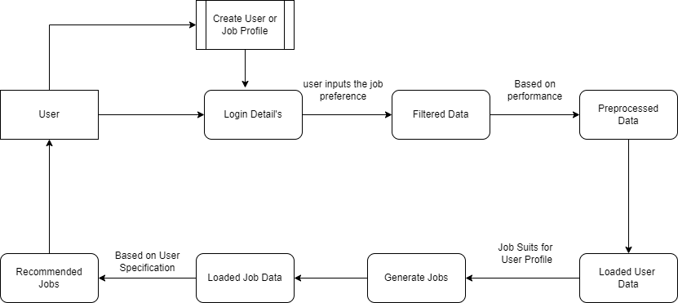

**User Stories**

Use the below template to list all the user stories for the product.

|  |  |  |  |  |  |  |
| --- | --- | --- | --- | --- | --- | --- |
| **User Type** | **Functional**  **Requirement (Epic)** | **User Story Number** | **User Story / Task** | **Acceptance criteria** | **Priority** | **Release** |
| Customer (Web user) | Registration | USN-1 | As a user, I can register for an account by entering my email, password, and confirming my password. | I can access my account / dashboard | High | Sprint-1 |
|  |  | USN-2 | As a user, I will receive confirmation email once I have registered for the application | I can receive confirmation email & click confirm | High | Sprint-1 |
|  |  | USN-3 | As a user, I can register for the application through Facebook | I can register & access the dashboard with Facebook  Login | Low | Sprint-2 |
|  |  | USN-4 | As a user, I can register for the application through Gmail | I can register & access the dashboard with Gmail Login | Medium | Sprint-1 |
|  | Login | USN-5 | As a user, I can log into the application by entering email & password | I can access the dashboard | High | Sprint-1 |
|  | Search | USN-6 | As a user, I can search for the desired companies | Companies related to the search terms are listed | High | Sprint-2 |
|  | Apply | USN-7 | As a user, I can apply for a company | Application is submitted to the company | High | Sprint-2 |
|  | Review | USN-8 | As a user, I can review the company | Review is listed on the company’s profile | Medium | Sprint-2 |
| Admin | Forward | USN-9 | As an admin, I must forward the applications  to the respective companies | The application is received  by the company | High | Sprint-1 |
|  | Send Confirmation | USN-10 | Confirmation mail is sent from the respected company | Confirmation is received by the user | High | Sprint-2 |
|  | Manage Review | USN-11 | As an admin, I must make the reviews appear on the company’s profile | Reviews appear on the company’s page | Low | Sprint-2 |